**ANALYSIS AND VISUALISATION**

# SECTION 1 - What are our customers doing?

## Are sales proportionally happening more on weekends?

* Marginally higher percent of sessions is converting to revenue on weekends and the revenue (page_value) per session is also slightly higher on weekends.



## Which regions are generating the most revenue currently?

* North America is the biggest. Asia and Eastern Europe the least

## 

## Is there any particular website traffic that stands out when generating sales?

* Search and Meta ads deliver most of the sales.

## 

## What percentage of time is spent on the website performing administrative/product or informational related tasks?



## What is the breakdown of months making the most sales*? (top 5 months below – cover 85% of sales)*

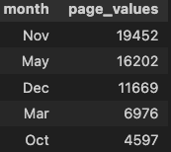

# SECTION 2 – What softwares do our customers use?

* The tables below show that Africa and Oceanian have slightly different software use with heavier use of Windows and less use of MacOS and Android, relative to other regions. From browser perspective, this translates to heavier use of Chrome in these two areas.
* The charts below show the following:
  + Close to 95% use Windows (53%), MacOS (21%) or Android (21%)
  + Over 75% are using desktops instead of mobile
  + Chrome (63%) and Safari (21%) account for nearly 85% of browsers used with Mozilla (7%) and Microsoft edge (4%) accounting for another 11%.
  + The use of Chrome on mobile (86%) is much higher than on desktop (55%). As a corollary, other platforms have a higher share on desktop than mobile.

*Percentage use of operating systems by region*

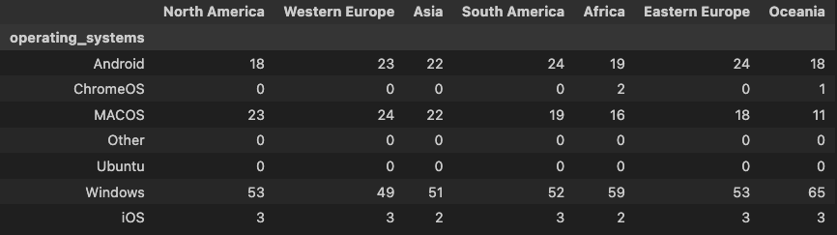

*Percentage use of devices by region*

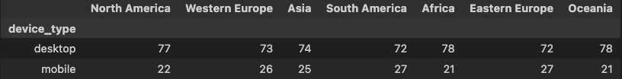

*Percentage use of browsers by region*



## OVERALL USE OF SOFTWARE (ACROSS COUNTRIES)







**Browsers on mobile**



**Browsers on desktop**



# SECTION 3 – Where does our traffic come from?

* Concentrate on SEO and social channels
  + Search contributes close to 60% of sales across regions (google search ~ 40%, bing search ~ 20%)
  + Meta ads are the second most important channel with close to 20% contributions – across Facebooks ads and Instagram ads are
  + Direct traffic is minimal across regions
* Bounce rates are highest in channels that contribute little to sales. But look at Yandex Search, TikTok page, DuckDuckGo Search, Youtube and Meta ads to reduce bounce rates.
* We get most sales from ads in two time periods – end of the year (Nov and Dec) and start of spring (March and May).





# SECTION 4- Where does our revenue come from?

* About two-thirds of sales happen in America and Western Europe
* Over 70% of sales happen on weekdays
* Close to 70% of sales come during May, Nov and December (holiday seasons in America and Western Europe)
* About 60% of sales comes through search, with another 25-30% through ads
* Percentage of sessions converting to sales does not vary drastically between new and returning customers (21-23%).









